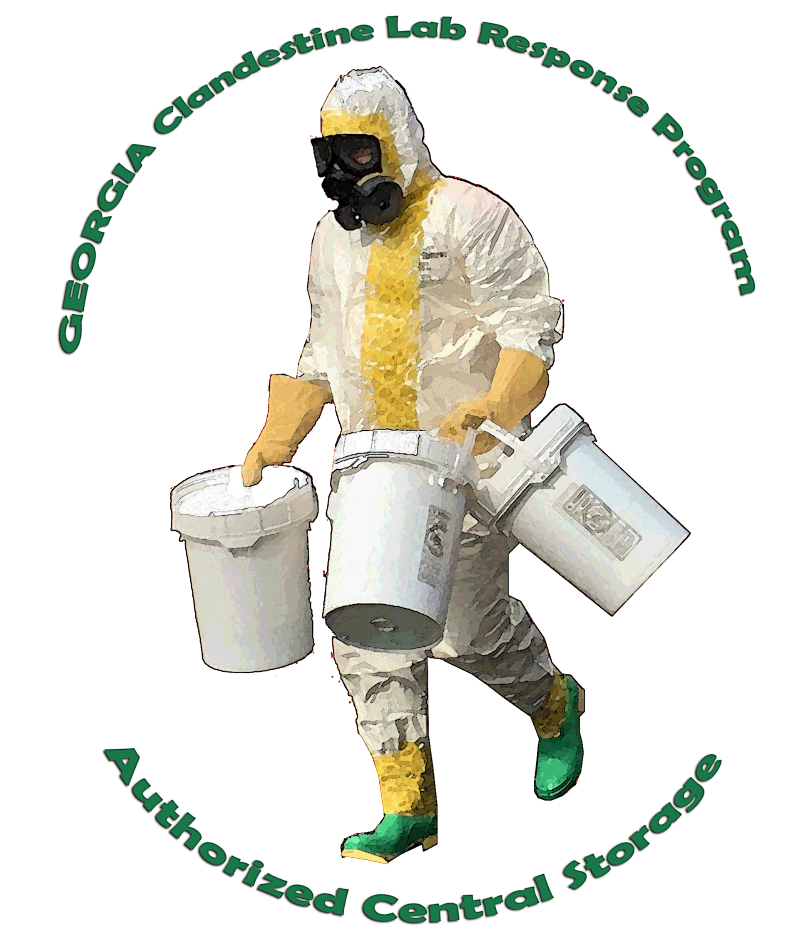
STATE OF GEORGIA
CLANDESTINE LABORATORY
RESPONSE PROGRAM

TRAINING ANNOUNCEMENT

Course Title:
DEA Authorized Central Storage (ACS) Course

Dates / Time:
March 7 through 8, 2018

Cost:
This course is provided at no cost by the DEA.
Lodging, meals and associated costs are the responsibility of the attendee’s employing agency.

Location:
Georgia Public Safety Training Center – Learning Resource Center

Course Coordinator:
Special Agent in Charge (SAC) Wayne Smith, GBI, 404-604-6127, wayne.smith@gbi.ga.gov

Course Description:
The ACS Course provides attendees with the knowledge and skills necessary to identify, classify, package, label, transport and store hazardous materials encountered at clandestine drug laboratories. Successful completion is required to access any Georgia ACS facility. It provides attendees with the training required under the regulatory and legal purview of the U.S. Department of Transportation, U.S. Environmental Protection Agency, and Occupational Safety and Health Administration. The format is a combination of lecture, demonstration and practical exercises.

The course is limited to a minimum of 20 and a maximum of 40 students. All students must be clan lab certified (Hazwoper) prior to attending and bring their Air Purifying Respirator (APR) to class. The DEA Academy is currently offering the Basic Clan Lab certification course at Quantico, VA. Any students requiring the Basic Clan Lab certification course must contact their DEA Filed Division Clan Lab Coordinator (CLC). In Georgia this Special Agent Robert Norton (404-569-7114, robert.m.norton@usdoj.gov)
This course may also be used as ACS refresher training provided it has been at least three (3) years since the student’s last ACS course.
Sizing information will be collected for a PPE package that will be provided to each student who successfully completes the course. These items are provided by the DEA and will be shipped directly to the attendee from DEA product vendors following completion of the course.

More information regarding the Georgia ACS program can be found at:
https://gbi.georgia.gov/meth-container-program

Course Registration Form

To register for the March 6-8, 2018 session of the DEA Authorized Central Storage (ACS) course, please complete this form and email it to Wayne Smith at wayne.smith@gbi.ga.gov.

Class size is limited to 40 students. Please register as soon as possible.

Name:____________________________________

Agency:___________________________________

Title:______________________________________

Email Address:______________________________

Cellular Telephone Number:____________________

Have you completed the 40 hour Basic Clandestine Lab Course? Yes No

More information regarding the Georgia ACS program can be found at:
https://gbi.georgia.gov/meth-container-program

